Joseph Silva Jr.

01/17/21

SNHU

CS 330

2-5 Milestone: Project Proposal

**Photographs:**

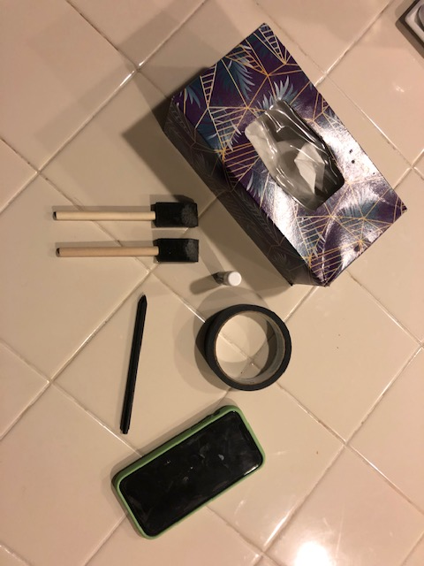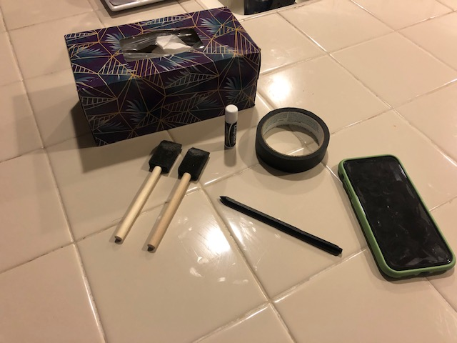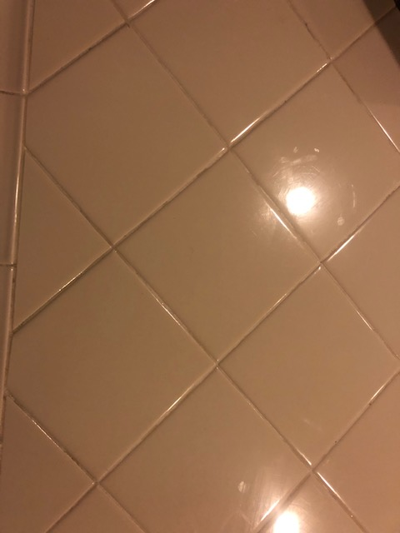

**Discussion – Objects to 3D:**

I selected multiple items around my kitchen, and I used my iPhone to capture three photographs for this assignment. As seen in the photographs above, I took an overhead photograph of the items, a sideview photograph of the items, and a photograph of the surface holding these items. In this assignment, the surface was my kitchen countertop, and my kitchen countertops are tiles separated by lines of grout. The following is a list of items in the photographs: a roll of duct tape, a tissue box, an iPhone 11, a pen with no cap, chap stick, and two foam paint brushes. For the items, I have chosen from these pictures are the paint brushes, duct tape, iPhone 11, pen, and the countertop tile. I chose these items because some of these items can be made using a single primitive shape and other objects need to combine 2+ primitive shapes to represent the item.

**Primitive Shapes:**

For the primitive shapes, I will start with the surface. Since my kitchen countertop are tiles separated by grout, I would use multiple planes to represent the tiles. I would also represent the grout by putting lines of separation between each plane. Next, I would use a cube to represent the iPhone 11 and then a torus to represent the duct tape. The last two types of items which are the paint brushes, and the pen will need 2+ primitive shapes in order to design the objects. For the pen’s body and the wooden bodies of the paint brushes, I would use cylinder shapes to describe these objects. I would use two laid down pyramids with one pyramid being smaller than the other to represent the tip of the pen. For the foam areas of the paint brushes, I would use a cube and a plane because the foam brush does have an area where there is a transition between it being flat to having a slight edge.